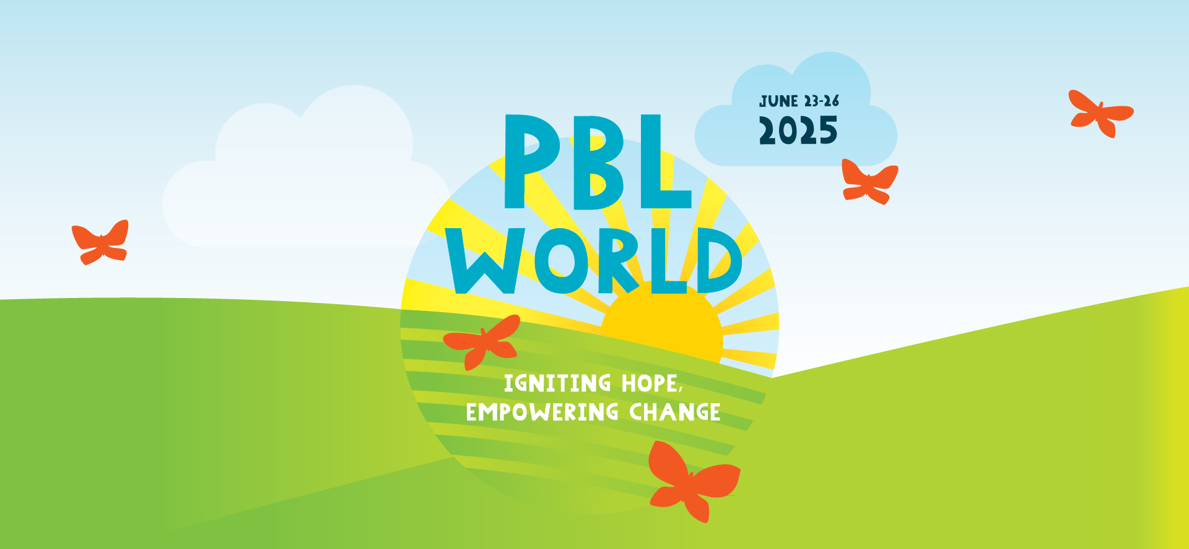

**Dear [Supervisor's Name],**

I am requesting your permission and financial support to attend **PBL World 2025**, held **June 23–26, 2025, in Napa Valley, California**. This premier conference will strengthen my practice in Project Based Learning (PBL) and directly support our school’s goals around student engagement, academic achievement, and future readiness.

PBL World offers immersive, hands-on workshops that model **Gold Standard PBL** and provide practical tools I can immediately implement in my classroom. This year, a **first-ever Alumni Student Panel** will offer invaluable insight into the long-term impact of PBL on students’ education and careers.

By attending **PBL World 2025**, I aim to:

* **Enhance PBL Practice & Build Capacity:** Learn from experienced practitioners, return with actionable strategies, and support colleagues in strengthening PBL implementation schoolwide.
* **Support School Goals**: Align my learning to our priorities such as fostering **success skills**—collaboration, communication, critical thinking, and creativity—as well as student agency and engagement.
* **Expand Professional Network**: Connect with educators from across the country, building relationships that extend beyond the conference

PBL has been shown to increase student motivation, deepen learning, and foster equitable outcomes by making learning more meaningful and relevant. I am confident that this experience will help me better serve our students and contribute to our team’s professional growth.

Details about the conference, including registration fees, travel, and logistics, can be found at: [www.pblworks.org/pbl-world](https://www.pblworks.org/pbl-world). In return, I’m committed to sharing key takeaways and with staff to help bring these best practices to life across our school.

Thank you for considering this request.

Thank you,  
**[Name]**